COS 226 Algorithms and Data Structures Fall 2009

Midterm
This test has 8 questions worth a total of 60 points. You have 80 minutes. The exam is closed book, except that you are allowed to use a one page cheatsheet. No calculators or other electronic devices are permitted. Give your answers and show your work in the space provided. Write out and sign the Honor Code pledge before turning in the test.
“I pledge my honor that I have not violated the Honor Code during this examination.”
Problem | Score
0
1
2
3
Sub 1


Problem | Score
4
5
6
7
Sub 2

Name:
Login ID:
Precept: P01 12:30 Anuradha P02 3:30 Berk P03 2:30 Corey
1
0. Miscellaneous. (1 point)
Write your name and Princeton NetID in the space provided on the front of the exam, and circle your precept number.
1. Analysis of algorithms. (8 points)
(a) Tilde notation is more precise than Big-Oh notation at describing the growth of a function because:
I. Tilde notation includes the coeﬃcient of the highest order term.
II. Tilde notation provides both an upper bound and a lower bound on the growth of a function.
III. Big-Oh notation suppresses lower order terms, so it does not necessarily accurately describe the behavior of a function for small values of N.
Circle the best answer.
(a) I only. | (d) I, II and III.
(b) I and II only. | (e) None.
(c) I and III only.

(b) Consider the following code fragment.
int count = 0; for (int i = 0; i < N; i++) for (int j = i+1; j < N; j++) for (int k = j+1; k < N; k++) if (a[i] + a[j] >= a[k]) count++;
Suppose that it takes 1 second to execute this code fragment when N = 1000. Using tilde notation, formulate a hypothesis for the running time (in seconds) of the code fragment as a function of N.

2. 8 sorting algorithms. (8 points) The column on the left is the original input of strings to be sorted; the column on the right
are the string in sorted order; the other columns are the contents at some intermediate step during one of the 8 sorting algorithms listed below. Match up each algorithm by writing its
3. Binary heaps. (8 points) Consider the following max-heap.

COS 226 MIDTERM, FALL 2009
number under the corresponding column. Use each number exactly once.
COS | ARC | ARC | ARC | COS | ART | CHM | CHE | REL | ARC
PHY | CHE | CHE | ART | COS | CEE | ART | COS | PHY | ART
ELE | COS | COS | CEE | ELE | CHM | ARC | CHM | PHY | CEE
COS | COS | COS | CHE | PHY | ARC | CEE | COS | ELE | CHE
MAT | ECO | ECO | CHM | ARC | COS | CHE | COS | PHI | CHM
MOL | ELE | EEB | COS | LIN | CHE | COS | ART | ORF | COS
LIN | GEO | ELE | COS | MAT | EEB | COS | CEE | ORF | COS
ARC | LIN | ELE | COS | MOL | COS | COS | ARC | COS | COS
ECO | MAE | ENG | COS | CHE | COS | COS | COS | ELE | COS
CHE | MAT | GEO | COS | ECO | COS | COS | COS | EEB | COS
MAE | MOL | LIN | COS | GEO | EEB | COS | MAE | MUS | COS
GEO | PHY | MAE | ECO | MAE | COS | ORF | GEO | GEO | ECO
ORF | ORF | MAT | ORF | EEB | COS | EEB | ORF | ORF | EEB
EEB | EEB | MOL | EEB | ELE | ELE | ENG | EEB | MAT | EEB
ENG | ENG | ORF | ENG | ENG | MAE | ELE | ENG | LIN | ELE
ELE | ELE | PHY | ELE | ORF | ELE | GEO | ELE | COS | ELE
COS | COS | ART | MOL | CEE | ECO | ELE | ECO | COS | ELE
ELE | ELE | CEE | ELE | COS | ENG | MAE | ELE | ECO | ENG
CEE | CEE | COS | ELE | EEB | MAT | EEB | LIN | CEE | GEO
EEB | EEB | EEB | EEB | ELE | LIN | ECO | EEB | CHE | LIN
ART | ART | ELE | PHY | ART | ELE | MUS | MOL | ART | MAE
MUS | MUS | MUS | MUS | MUS | MUS | PHI | MUS | MAT | MAT
PHI | PHI | ORF | PHI | ORF | MAT | ORF | PHI | MAE | MAT
ORF | ORF | PHI | ORF | PHI | ORF | LIN | ORF | ELE | MOL
COS | COS | COS | GEO | COS | GEO | PHY | MAT | COS | MUS
PHY | PHY | PHY | PHY | COS | ORF | MOL | PHY | MOL | ORF
COS | COS | COS | LIN | MAT | MOL | MAT | COS | COS | ORF
MAT | MAT | MAT | MAT | PHY | PHY | MAT | MAT | EEB | ORF
CHM | CHM | CHM | MAT | CHM | ORF | ORF | ELE | CHM | PHI
ORF | ORF | ORF | ORF | COS | PHY | ELE | ORF | ENG | PHY
COS | COS | COS | MAE | ORF | PHI | REL | PHY | COS | PHY
REL | REL | REL | REL | REL | REL | PHY | REL | ARC | REL
-- | -- | -- | -- | -- | -- | -- | -- | -- | --
0 |  |  |  |  |  |  |  |  | 1

(0) Original input | (4) Shellsort | (7) Quicksort
(1) Sorted | (13-4-1 increments) | (standard, no shuﬄe)
(2) Selection sort | (5) Mergesort (top-down) | (8) Quicksort (3-way, no shuﬄe)
(3) Insertion sort | (6) Mergesort | (9) Heapsort
 | (bottom-up)

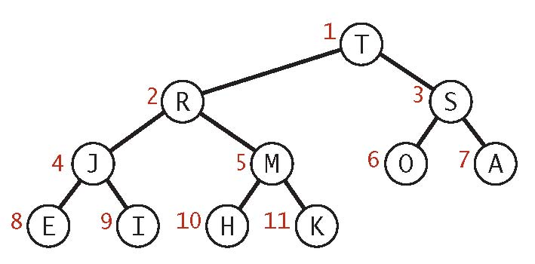
(a) The max-heap above resulted after a sequence of insert and remove-the-maximum operations. Assume that the last operation was an insert. Which key(s) could have been the one inserted last? Circle all possible keys.
AEHIJKMORST
(b) Draw the heap that results after deleting the maximum key from the heap above.
4. Red-black trees. (8 points) Consider the following left-leaning red-black tree. Add the key Z, then add the key P.
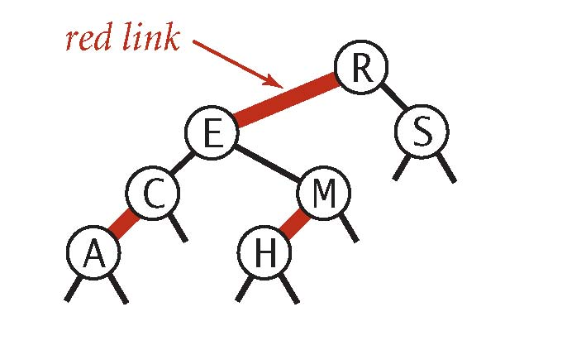
(a) Draw the resulting left-leaning red-black tree.
(b) How many left rotations, right rotations, and color ﬂips are performed in total to insert the two keys?

−−− left rotation(s) −−− right rotation(s) −−− color ﬂip(s)
5. Hashing. (6 points) Suppose that the following keys are inserted in some order into an initially empty linear-probing hash table of size 7, using the following table of hash values:

key
A B C D E F G
hash
3 1 4 1 5 2 5
Which of the following could be the contents of the linear-probing array?
I.
0 | 1 | 2 | 3 | 4 | 5 | 6
G | B | D | F | A | C | E

II.
0 | 1 | 2 | 3 | 4 | 5 | 6
B | G | D | F | A | C | E

III.
0 | 1 | 2 | 3 | 4 | 5 | 6
E | G | F | A | B | C | D

Circle the best answer.
(a) I only. (d) I, II and III.
(b) I and II only. (e) None.
(c) I and III only.
6. Data structures. (9 points)
Given an N-by-N grid of sites, you wish to repeated select a site (i, j) at random among all sites not yet chosen. Consider the following code fragment for accomplishing this task.
ArrayList<Integer> sites = new ArrayList<Integer>(); for (int id = 0; id < N*N; id++) { // for each site,
sites.add(id); // add to end of list } while (!sites.isEmpty()) {
int n = sites.size(); // number of elements left in list int r = StdRandom.uniform(n); // between 0 and n-1 int id = sites.remove(r); // remove and return item at index r inti=id/N,j =id%N; //site(i,j) ...
}
(a) The java.util.ArrayList data type is implemented using an array (with doubling and halving). What is the order-of-growth of the worst-case running time of the code fragment as a function of N? Circle the best answer.
NN log NN2 N2 log NN3 N4 2N
(b) Which data structure that we’ve encountered in this course should you use instead of java.util.ArrayList? Circle the best answer.
i. union-ﬁnd
ii. stack / queue
iii. deque
    - randomized queue
    - binary heap
    - vi. red-black tree
    - vii. hash table
    - (c) For the improved version in (b), what is the order-of-growth of the worst-case running time as a function of N? Circle the best answer.

NN log NN2 N2 log NN3 N4 2N
7. Generalized queue. (12 points) Design a data structure that supports the following API for a generalized queue.
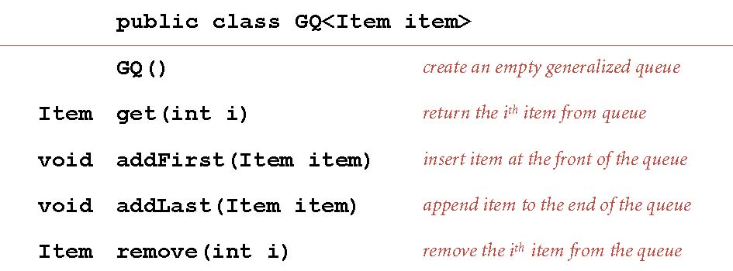
Here is a sample client, showing the contents of the queue after each insertion / deletion.
GQ<String> gq = new GQ<String>(); gq.addFirst("A"); // A gq.addFirst("B"); // B A gq.addLast("C"); // B A C gq.addLast("D"); // B A C D gq.addFirst("E"); // E B A C D gq.addFirst("F"); // F E B A C D gq.addLast("G"); // F E B A C D G
String s1 = gq.get(2); // s1 = "B" gq.remove(2); // F E A C D G String s2 = gq.get(2); // s2 = "A"
Your data structure should implement all operations in logarithmic time (or better) as a function of the size of the queue. You may use any of the data structures we have discussed in this course in your solution. Your solution will be graded for correctness, eﬃciency, clarity, and conciseness.
For half-credit, describe a data structure that implements all operations except remove in constant amortized time.
(b) Describe how to implement get().
(c) Describe how to implement addFirst() and addLast().
(d) Describe how to implement remove().

(a) Describe the underlying data structure. | Draw it after the ﬁrst 7 insertions for the
example above.

